April 2012

CENTRAL MISSOURI CHAPTER
SAFARI CLUB INTERNATIONAL

Safari Wish Hunts
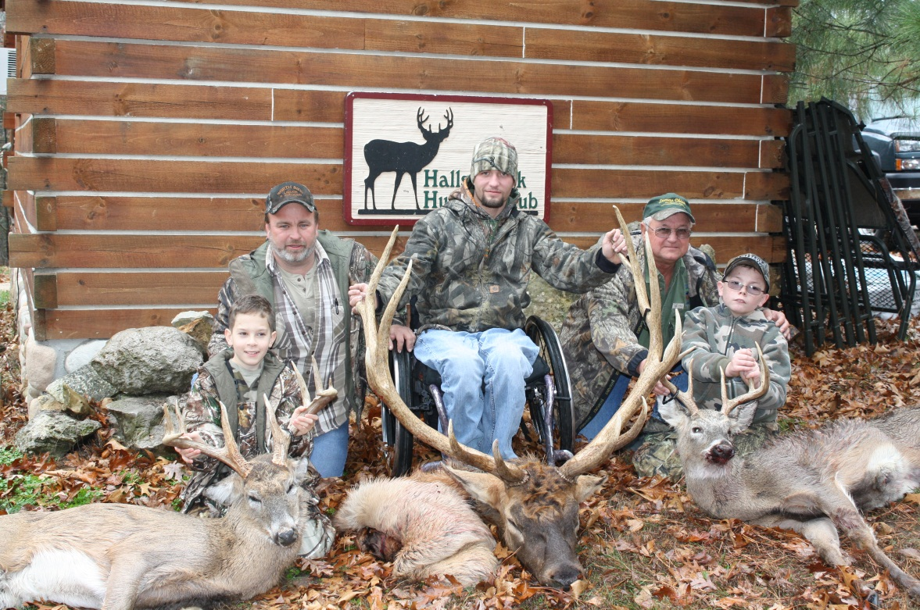
L to R: Clay Miller, Walter Coleman (representative from our Chapter), Tyler Huffman,
Bill Moore (our Chapter’s Safari Wish coordinator), and Riley Tade

Three Safari Wish hunts were held by the Chapter December 18 and 19, 2011 for three very worthy hunters. The hunts took place at Halls Creek Outfitters located a few miles southeast of Fulton for Tyler Huffmann, Riley Tade and Clay Miller. Approximately 50 people including families of the hunters and members of the Central Missouri Chapter of SCI attended the enjoyable event. Tyler Huffman, a wounded veteran, harvested a very nice elk the evening of December 18 and commented to one of the chapter members that he had always wanted to go elk hunting since he was a child. Riley Tade and Clay Miller, the two youth participating, both harvested very nice whitetail bucks. Several chapter board members attended and helped with the event that was coordinated by board member Walter Coleman.

Following are photos of our three Safari Wish hunters and some comments from them or their family members about the hunt.

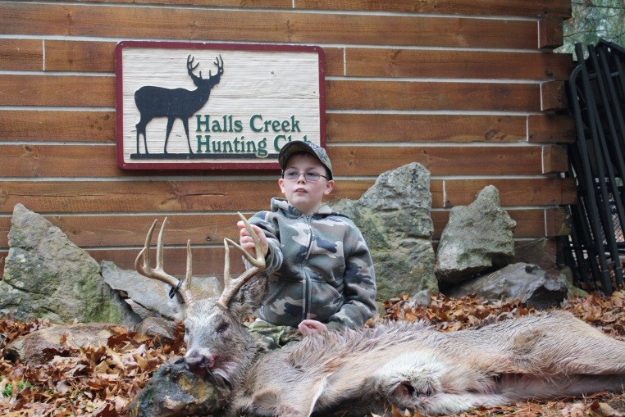
Riley Tade with his 8 point, 110-120 class deer

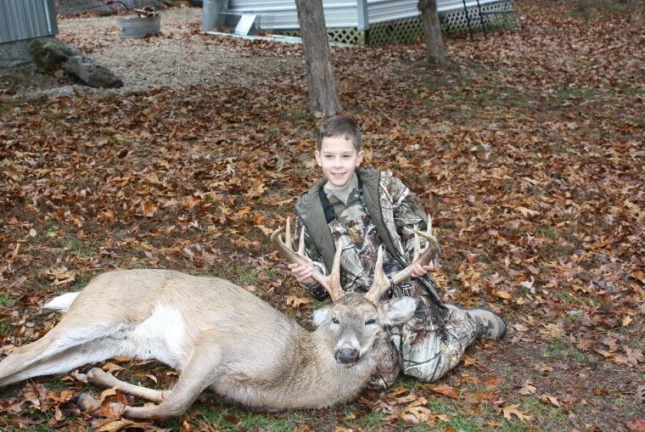 Clay Miller with his 11 point, 120-130 class deer

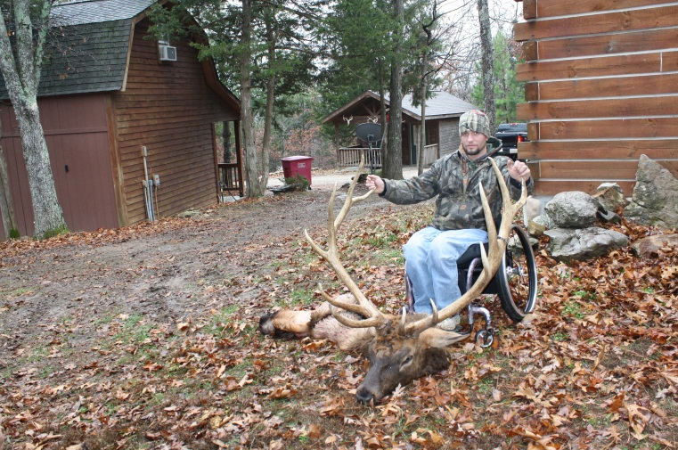
Tyler Huffman with his 6x6, 320 score elk

From Mark Tade, Riley’s grandfather: Just wanted to take a moment to thank you and everyone associated with the Central Missouri Chapter of Safari Club International for the hunt that my grandson Riley was able to enjoy. He will never forget it nor will Steve and myself. It was very special to me to be included and be a part of a 3 generation experience. The hospitality, the accommodations, the food, and everything was over the top on your part. Thanks for partnering with Halls Creek Outfitters to make this possible for these three guys, who will be ever thankful. Please pass my thanks on to all involved. I know it was a big effort on everyone's part.

Got home fine on Monday, stopped in Rolla and got pictures made to take to scouts with us. The scouts were really impressed with Clay's big deer. Clay went to school and showed the teachers and kids and they really liked the deer too. Don't know how to say thanks to all your members for giving Clay a chance to BE A REAL BOY. This really put him a cut above some of the boys in school. The best to all of you this blessed season of the Lord's birth. See you when we come and pick up the deer. Thanks again, Ruth Woodson

Tyler Huffman grew up in Millersburg and went to Fulton High School. The 24-year-old spent 3 1/2 years as a Marine, and was deployed to Afghanistan the beginning of October 2010. On December 3, 2010, while on patrol, he was shot in the right side of his chest. He was flown to a medical hospital in Germany and finally ended up in Richmond, Virginia for 2 months. Tyler got home to Fulton with his wife and their 1 1/2-year-old son, Matthew, on March 5, 2011. The shooting left him unable to move his legs, but Tyler said he still wants to be active and he “loves to be outside”. He has been very surprised by the number of people who don’t know him personally, but still want to show their support. Tyler said the hunt was something he probably would not have been able to do without SCI. He said it was the best time he’s had and then he said thank you the best way possible – with the big smile on his face!

Deer Hunters Donate Over 28,000 Pounds of Venison for Charities in Central Missouri

The Share the Harvest Program sponsored in central Missouri by the Central Missouri Chapter of Safari Club International (SCI) during the 2011/2012 deer seasons resulted in deer hunters donating 28,300 pounds of venison for charities in central Missouri. A total of 460 whole deer and several partial deer were donated. “We really appreciate the venison donations by deer hunters in this area for it comes at a time when there is a great need for food by charities in central Missouri,” said Earl Cannon, coordinator of the program for the SCI chapter.

The Conservation Federation of Missouri and the Central Missouri Chapter of SCI paid the processing cost for whole deer donations. “Our chapter wants to thank the deer hunters, meat processors, charities, Missouri Department of Conservation, Conservation Federation of Missouri, Safari Club International Foundation, Missouri Food Bank Association, Missouri Department of Economic Development, Governor Jay Nixon, news media, chapter members and all others who helped make the program so successful,” said Jim Lightsey, president of the SCI chapter.

Donations by processing plants were as follows:
Russellville Locker, Russellville – 5,813 pounds
Hartman’s Custom Meat Processing, New Bloomfield – 1,460 pounds
Crane’s Meat Processing, Ashland – 5,875 pounds
R & R Processing, Auxvasse – 3,530 pounds
Swiss Meat & Sausage Co., Hermann – 2,810 pounds
Mexico Meat & Produce, LLC, Mexico – 5,760 pounds
Hanson Hills Campground, Kingdom City – 2,040 pounds
Horn’s Meat Processing, Fulton – 1,020 pounds

The distribution of venison to the charities served was as follows:
Serve, Inc., Fulton – 4,808 pounds
First United Methodist Church Food Pantry, Jefferson City – 500 pounds
New Life Evangelistic Center, Jefferson City, New Bloomfield, Columbia – 480 lbs.
California United Methodist Church Food Pantry, California – 1,200 pounds
Samaritan Center, Jefferson City – 1,400 pounds
Food Bank for Central & Northeast Missouri, Columbia – 5,875 pounds
The Salvation Army, Jefferson City – 1,865 pounds
The Salvation Army, Columbia – 889 pounds
Oak Chapel Missionary Baptist Church, New Bloomfield – 480 pounds
The Help Center, Mexico – 5,760 pounds
Helping Hands Outreach Center of Gasconade County, Owensville and
Hermann Community Food Pantry, Hermann – 2,810 pounds
Hope House, Lake Ozark – 1,200 pounds
First Baptist Church Food Pantry, Guthrie – 500 pounds
Eldon Ministerial Alliance Food Pantry, Eldon – 600 pounds
Holts Summit Soup Kitchen, Holts Summit - 180 pounds

For additional information contact: Earl Cannon, Coordinator Sportsmen Against Hunger/Share the Harvest Program, Central Missouri Chapter of SCI at 573-636-4292.

Annual Membership Fun Day & Shoot –
Saturday, May 19th

Our Annual Membership Fun Day and Shoot will be held on Saturday, May 19, 2012. This event is designed to be a fun day for the entire family. We will convene about noon at the home of Glenn and Dawn Danuser. The shooting range will be available as well as the trap range for anyone wishing to try their hand at trapshooting (please bring clay birds). You may bring any firearm that you would like to shoot but don’t forget to bring your own ammo. There is an outdoor archery range by the house so bring your bow and arrows (no broad heads). You can bring golf carts, 4-wheelers or side by sides. When the shooting is finished, we will enjoy food and drink (probably between 3:00 and 4:00 p.m.). The Chapter will furnish the drinks, ribs, brisket and beans. Please bring a side dish to share. In the past, the weather has cooperated and this has been a fun event with great food!

Directions to 6050 CR 113, Fulton, Missouri: From Business Route 54, take Route O (you’ll be going East) for 1.4 miles, turn left on Route UU and follow for about 4 miles. Turn right on CR 113, it’s the first drive on left.

Banquet and Auction
August 11, 2012

We are making plans for our 2012 banquet and auction and want to be sure you save this date on your calendar so you can join in on the fun! Since the facility worked so well last year, we are planning to again host the event at St. Peter Catholic Church in Fulton, Missouri.

4-Wheeler Raffle

We are having a raffle for a 2012 Honda Rancher 4x4 in camo with a standard shift. The tickets are $20.00/each or three for $50.00. If you’d rather have cash, we are also offering a $4,000 cash option. A note must be made on the raffle ticket if you choose the cash option. The drawing will be held on August 11, 2012 or sooner if all the tickets are sold out. As always, the proceeds go to help our charitable projects such as Safari Wish, Share the Harvest, etc. If you would like to purchase a raffle ticket, contact Walter Coleman at 573-220-1758. We appreciate your support and so do the Safari Wish and Share the Harvest recipients!

Board Member Election

There are three individuals running for our three available board member positions. Below is a brief description of each candidate. If you have other candidates you wish to vote for in lieu of the names on the ballot, you may write in up to 3 names of your own choosing. They must be current members of our organization.

Jamie Coleman – Jamie is currently a board member and is our treasurer. She and her husband became involved with SCI when their son was a recipient of a Safari Wish hunt several years ago. She assists in gathering items for our annual banquet and auction and works at the registration table the night of the auction. Jamie enjoys hunting.

Travis Maddox – Travis recently became a member of SCI as well as our local chapter. He would like to further his involvement in the organization by becoming a board member. He has been a taxidermist for seven years and loves wildlife and the outdoors. He has a little girl that loves to fish and looks forward to when she is old enough to hunt.

Mike Nolting – Mike is currently on the board and has been a member of SCI since 2004. He and his wife Tanya and daughter Darby always assist with the banquet and auction. Mike has also been involved in helping distribute venison for our Share the Harvest program.

.

Please cast your vote below, re-fold this sheet and return it to us by April 30, 2012.
We encourage everyone to return the postage-paid ballot!

Check up to 3 names. You are allowed to write in current members and vote for them as one of the three board members.
___ Jamie Coleman
___ Travis Maddox
___ Mike Nolting
___ __________________________________
___ __________________________________
___ __________________________________

Central Missouri Chapter of
Safari Club International
P.O. Box 6362
Fulton, MO 65251

------------------------------------------------------------------------------------------------------------------------------------------
Fold Here 1st

Fold Here Last and Close with Tape
------------------------------------------------------------------------------------------------------------------------------------------

